**Snippet 1:**

public class Main {

public void main (String [] args) {

System.out.println("Hello, World!");

}

}

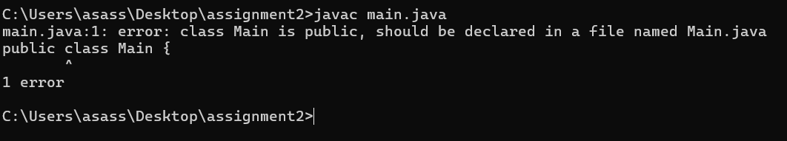**What error do you get when running this code?**

1. In main method static keyword is missing. Bina class ka object banaye main method ko access kar sake static member does not deal with object.
2. Add static keyword in main method.

**Snippet 2:**

public class Main {

static void main (String [] args) {

System.out.println("Hello, World!");

}

}

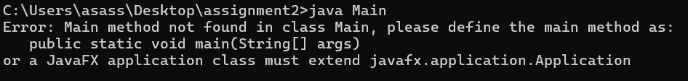 **What happens when you compile and run this code?**

1. In class Name we cannot use public keyword.
2. In main method public keyword is missing.
3. It is access modifier class ke bahar se main method ko access kar sake ya call kar sake jvm will not access the public method then program will not execute.

**Snippet 3:**

public class Main {

public static int main (String [] args) {

System.out.println("Hello, World!");

return 0;

}

}

**What error do you encounter? Why is void used in the main method?**

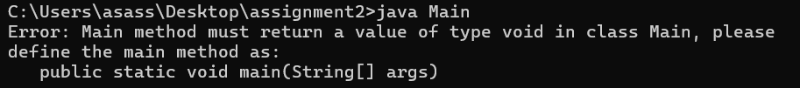

1. Void main function returns no return value.
2. Remove int and Add void function in main method

**Snippet 4:**

public class Main {

public static void main () {

System.out.println("Hello, World!");

}

}

What happens when you compile and run this code? Why is String [] args needed?

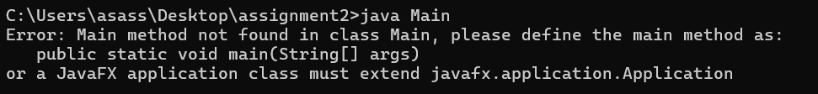

1. String is pre-defined class its first letter is capital ye array type variable h if we have to pass any from the main method we string arguments and it is the part of syntax. We have to write it.

**Snippet 5:**

public class Main {

public static void main(String[] args) {

System.out.println("Main method with String[] args");

}

public static void main(int[] args) {

System.out.println("Overloaded main method with int[] args");

}

}

Can you have multiple main methods? What do you observe?

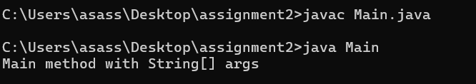

1.there is one main method usded.

**Snippet 6:**

public class Main {

public static void main (String [] args) {

int x = y + 10;

System.out.println(x);

}

}

**What error occurs? Why must variables be declared?**

* We must declare the variable y.
* Value of y also initialized. like y=10.
* Then it will run.

**Snippet 7:**

public class Main {

public static void main (String [] args) {

int x = "Hello";

System.out.println(x);

}

}

What compilation error do you see? Why does Java enforce type safety?

* Here we are using int datatype so we can not use string for variable x .
* We have to put integer value in it.

**Snippet 8:**

public class Main {

public static void main(String[] args) {

System.out.println("Hello, World!"

}

}

**What syntax errors are present? How do they affect compilation?**

* We get expected error because it should in brackets and semi colon at the end.

**Snippet 9:**

public class Main {

public static void main (String [] args) {

int class = 10;

System.out.println(class);

}

}

**What error occurs? Why can't reserve keywords be used as identifiers?**

* We get not a statement error. we can not used class as identifiers because class is reserved keyword in java.